 Shipwrecked

|  |  |  |
| --- | --- | --- |
| Controls |  |  |
| Move | Left Joystick | WASD, Up/Down/Left/Right |
| Camera Movement | Right Joystick | Move mouse |
| Initial Special Ability | L1 | Q |
| Second Special Ability | R1 | E |
| Aim | L2 | Right Click |
| Shoot | R2 | Left Click |
| Sprint | L3 | Shift |
| Front Roll | R3 | C |
| Jump | A/X | Space bar |
| Reload | X/Square | R |
| Revive | Y/Triangle | G |
| Pause | Start | Escape key |
| Emotes | D-Pad | Keys 1-4 |

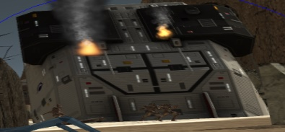

Protect your ship, which starts at 1000 HP. Don’t let it drop to 0 or you lose!

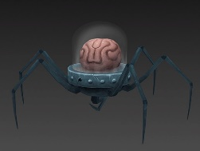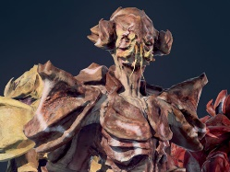

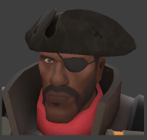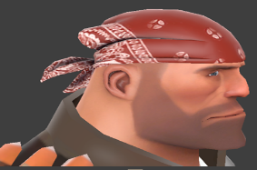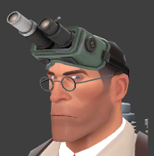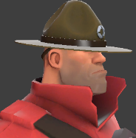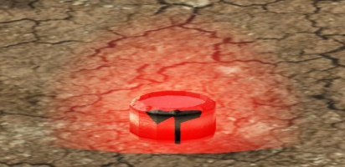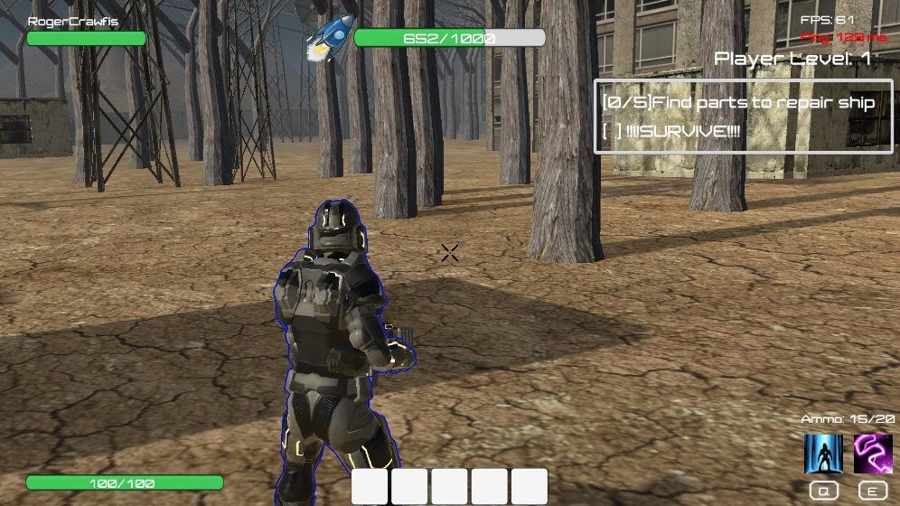

Kill Crab Aliens and Spider Brains to gain experience, level up and unlock special abilities for your character!

**Weapon**: Martian Assault Rifle (Base Damage: 7 | Fire Rate: 7.5/Sec | Ammo: 15 | Reload Speed: 1.5 Sec)

**First Skill**: Apply Field Dressing

**Second Skill**: Autofire

**Weapon**: Laser Pistol (Base Damage: 6 | Fire Rate: 6/Sec | Ammo: 12 | Reload Speed: 2 Sec)

**First Skill**: Heal Others

**Second Skill**: Medical Aura

**Weapon**: High Explosive Missile Launcher (Base Damage: 30| Fire Rate: 1/2 Sec| Ammo: 2 | Reload Speed: 4 Sec)

**First Skill**: Construct Turret

**Second Skill**: Repair Ship

**Weapon**: Atharian Assault Rifle (Base Damage: 5 | Fire Rate: 10/Sec | Ammo: 20 | Reload Speed: 2.5 Sec)

**Built-in skill**: Autofire

**First Skill**: Rampage

**Second Skill**: Stun Enemy

Captain Hugo

Stiglitz (Captain)

Mechanic Mike Raider (Grease)

Doctor Tyler

Yusko (Doc)

Sergeant Peter Fremin (Sarge)

Collect five ship parts scattered around the map to escape the planet and win the game!

**Frame rate**

**Ping**

**Player level**

**Second special ability**

**Mission Objectives**

**Ammo**

**Player health**

**Teammate health**

**Ship health**

**First special ability**

**Ship parts collected**